**Contact Management Systems**

**Entity Relationship Diagram:**

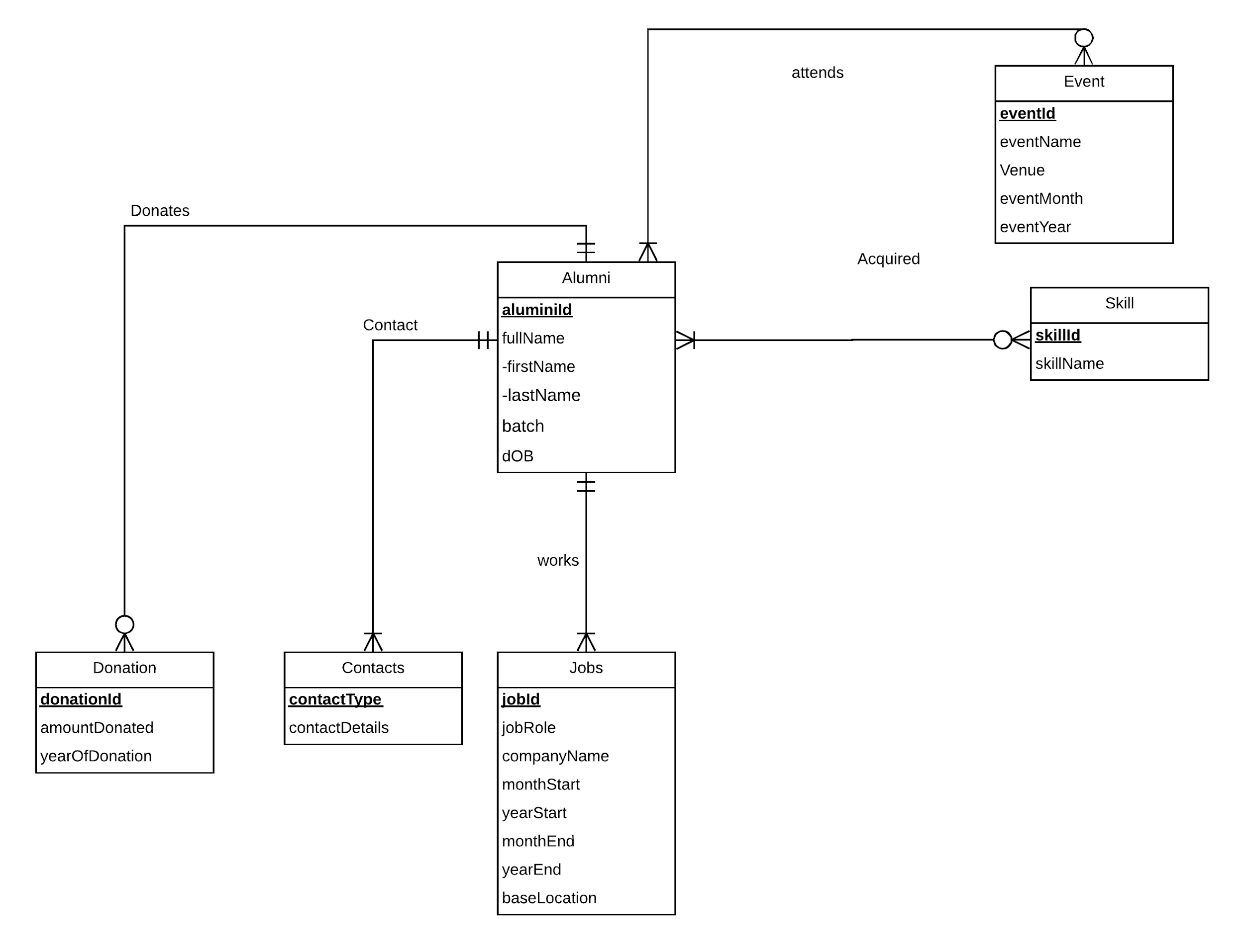

SQL Queries

1. Alumni Table:

CREATE TABLE [Smith.Alumni] (

       alumniId varchar (10) NOT NULL,

       firstName varchar(20),

       lastName varchar(20),

       batch char(4),

       dOB date,

       CONSTRAINT pk_smith_alumni PRIMARY KEY (alumniId) );

1. Job Table

CREATE TABLE [Smith.Jobs] (

       jobId varchar (10) NOT NULL,

       jobRole varchar(100),

       companyName varchar(100),

       monthStart char(10),

       yearStart char(4),

       monthEnd char(10),

       yearEnd char(10),

       baseLocation varchar(100),

       alumniId varchar(10),

       CONSTRAINT pk_smith_jobs PRIMARY KEY (jobId),

       CONSTRAINT fk_Jobs_alumniId FOREIGN KEY (alumniId)

             REFERENCES [Smith.Alumni] (alumniId)

             ON DELETE CASCADE ON UPDATE NO ACTION);

1. Event Table

CREATE TABLE [Smith.Event] (

eventId varchar (10) NOT NULL,

eventName varchar (20),

venue varchar (20),

eventMonth char (3),

eventYear char (4),

alumniId varchar(10),

CONSTRAINT pk_smith_event PRIMARY KEY (eventId),

CONSTRAINT fk_event_alumniId FOREIGN KEY (alumniId)

);

1. Skill Table

CREATE TABLE [Smith.Skill](

skillId varchar (10),

skillName varchar (20),

alumniId varchar(10),

CONSTRAINT pk_smith_skill PRIMARY KEY (skillId),

CONSTRAINT fk_skill_alumniId FOREIGN KEY (alumniId)

);

1. Contact Table

CREATE TABLE [Smith.contact] (

contactType varchar(10),

contactDetails varchar (20),

alumniId varchar (10),

CONSTRAINT pk_smith_contact PRIMARY KEY (contactType),

CONSTRAINT fk_contact_alumniId FOREIGN KEY (alumniId)

);

1. Donation Table

CREATE TABLE [Smith.Donation](

donationId varchar (10),

amountDonated varchar (10),

yearOfDonation char (4),

CONSTRAINT pk_smith_donation PRIMARY KEY (donationId),

CONSTRAINT fk_donation_alumniId FOREIGN KEY (alumniId)

);